Name - Pranav Unkule

Roll No - 160

PRN - 0120190250

**LAB: RAM**

**HDL Code**

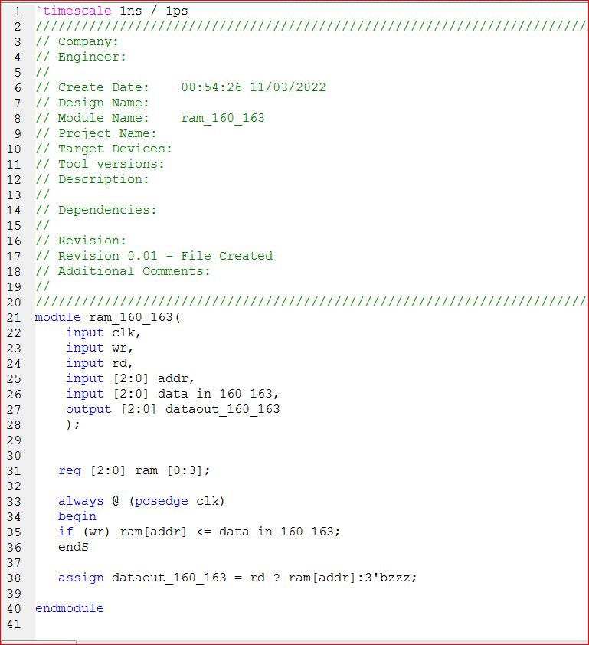

**Text Bench Code**

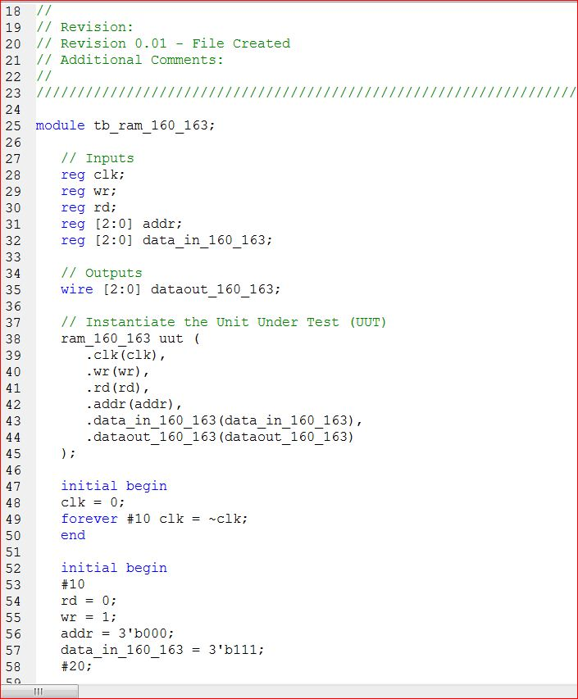

**Schematic**

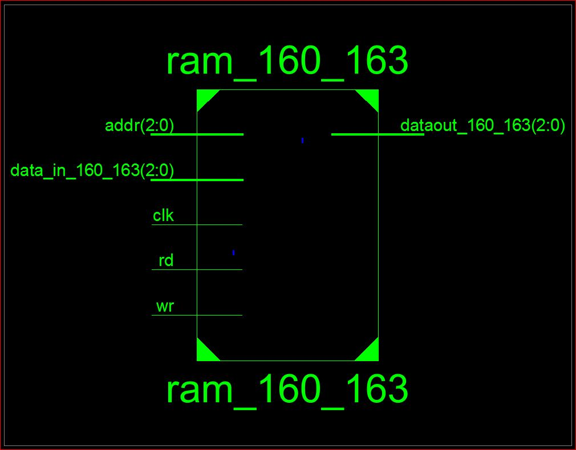

**Simulation**

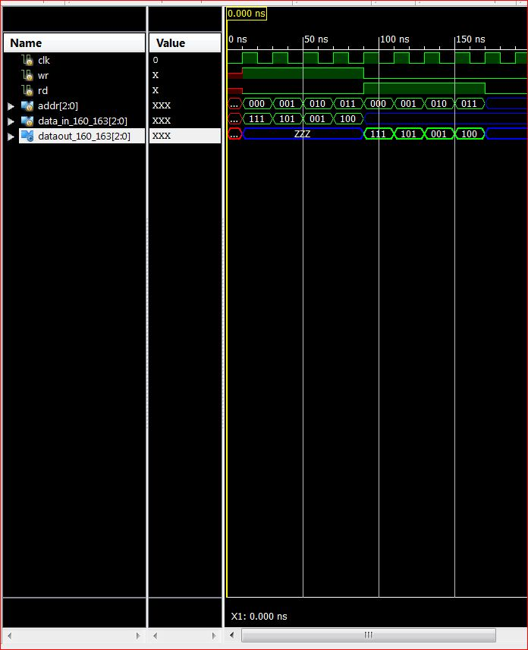

**UCF File**

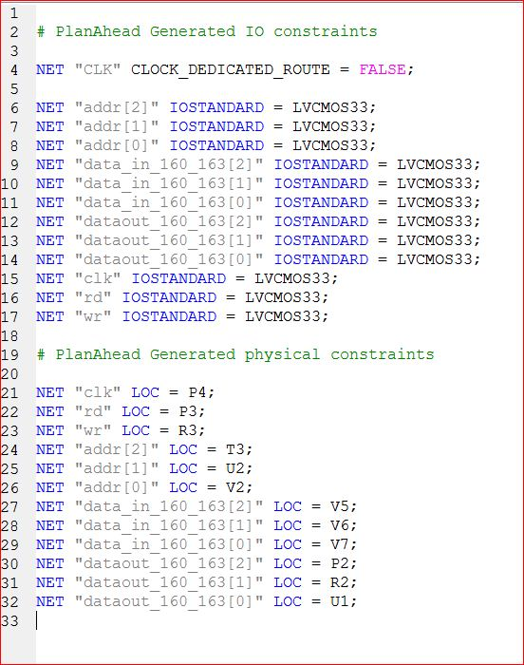

**Design Summary**

